**Review Worksheet: Cultural Evolution**

**Name: ……………………………………………………………..**

*Do these questions, using your learning resources. Look at the “marks” to give you an idea of the level of detail required in the response (formative only – does not count towards your grade). At the end, mark your work, correct it, and fill in the reflection section. Questions marked * require you to use reasoning, inferring and application of knowledge, or perhaps extra research to get the answer. It won’t be right there in the text.*

1: Write yes or no to indicate which of the following cultural practices were known to occur with each of the Hominin species:

(1 mark for each fully correct row – 9 marks)

|  |  |  |  |  |  |
| --- | --- | --- | --- | --- | --- |
|  | ***Australopithecus*** | ***Homo habilis*** | ***Homo erectus*** | ***Homo neanderthalensis*** | ***Homo sapiens*** |
| Made and Used tools | *Yes?* | *Yes* | *Yes* | *Yes* | *Yes* |
| Built shelters | *No* | *No* | *Yes* | *Yes* | *Yes* |
| Made and used fire | *No* | *No* | *Yes* | *Yes* | *Yes* |
| Ate meat | *No* | *Yes* | *Yes* | *Yes* | *Yes* |
| Complex language | *No* | *No* | *Yes?* | *Yes* | *Yes* |
| Wore clothing | *No* | *No* | *No* | *Yes* | *Yes* |
| Buried their dead | *No* | *No* | *No* | *Yes* | *Yes* |
| Made art | *No* | *No* | *No* | *No* | *Yes* |
| Symbolic thought | *No* | *No* | *No* | *No* | *Yes* |

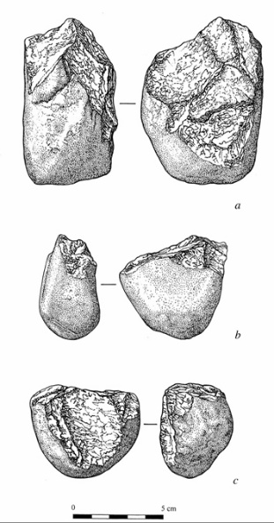2: Name the following tool types and which species made them.

(6 marks)

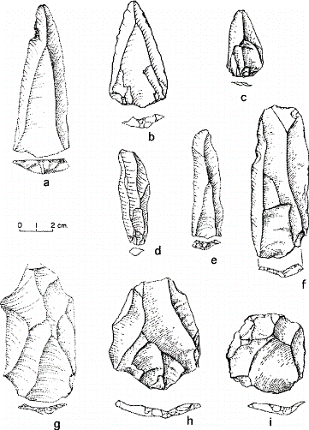

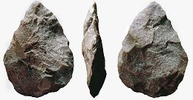

|  |  |  |
| --- | --- | --- |
| *Acheulean Hand Axe* | *Mousterian Tools* | *Oldowan Tools* |
| *Homo erectus* | *Homo neanderthalensis* | *Homo habilis and maybe Australopithecus* |

3: Describe trends seen in tool culture between *Australopithecus* and *Homo sapiens.*

(3 marks)

*…………………………………………………………………………………………………………………*

*…………………………………………………………………………………………………………………*

*…………………………………………………………………………………………………………………*

*…………………………………………………………………………………………………………………*

4: a) For each of the tools below, decide which *Homo sapiens* Cro Magnon tool culture (that we

have learned about in class) they belong to, and give reasons for your answer.

(9 marks)

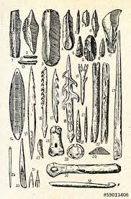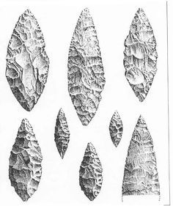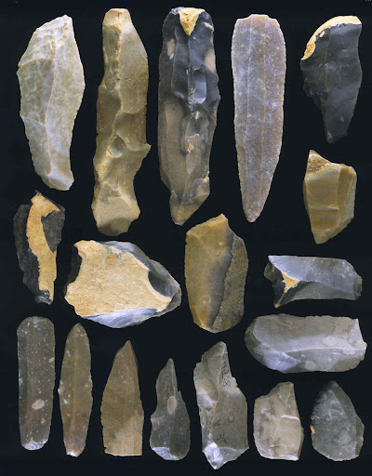

|  |  |  |
| --- | --- | --- |
| *Aurignacian* | *Magdelanian* | *Solutrean* |
| *Tools made of stone*  *Predominantly blade tools* | *Wide variety of specialised tool types*  *Variety of materials – stone, bone, antler* | *Very fine pressure flaking*  *Leaf shaped blade* |

b) Name which of the tool cultures above is the oldest, and which is the most recent.

(1 mark)

*………………………………………………………………………………………………………………*

5: What was the Neolithic revolution and why was it important?

(4 marks)

*………………………………………………………………………………………………………………..*

*………………………………………………………………………………………………………………..*

*………………………………………………………………………………………………………………..*

*………………………………………………………………………………………………………………..*

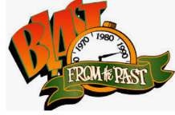6: Describe the steps of inflammation in detail, from the moment of tissue injury until the stage is set for tissue healing.

(11 marks)

*…………………………………………………………………………………………………………………………….*

*…………………………………………………………………………………………………………………………….*

*…………………………………………………………………………………………………………………………….*

*…………………………………………………………………………………………………………………………….*

*…………………………………………………………………………………………………………………………….*

*…………………………………………………………………………………………………………………………….*

*…………………………………………………………………………………………………………………………….*

*…………………………………………………………………………………………………………………………….*

*…………………………………………………………………………………………………………………………….*

*…………………………………………………………………………………………………………………………….*

*…………………………………………………………………………………………………………………………….*

*…………………………………………………………………………………………………………………………….*

*…………………………………………………………………………………………………………………………….*

*…………………………………………………………………………………………………………………………….*

*…………………………………………………………………………………………………………………………….*

*…………………………………………………………………………………………………………………………….*

*…………………………………………………………………………………………………………………………….*

*…………………………………………………………………………………………………………………………….*

*…………………………………………………………………………………………………………………………….*

*…………………………………………………………………………………………………………………………….*

Go back and mark your work using the marking key provided. What score did you get? /43

*I included enough detail in my answers.*



*I was able to find information in the text/powerpoint presentation.*

*I was able to reason and infer where the information wasn’t directly in the text (questions with *).*

*I marked my work and wrote down any answers where I missed marks.*